**Ideation Phase**

**Define the Problem Statements**

|  |  |
| --- | --- |
| Date | 31 January 2025 |
| Team ID | **LTVIP2025TMID45799** |
| Project Name | TrafficTelligence: Advanced Traffic Volume Estimation with Machine Learning |
| Maximum Marks | 2 Marks |

**Customer Problem Statement Template:**

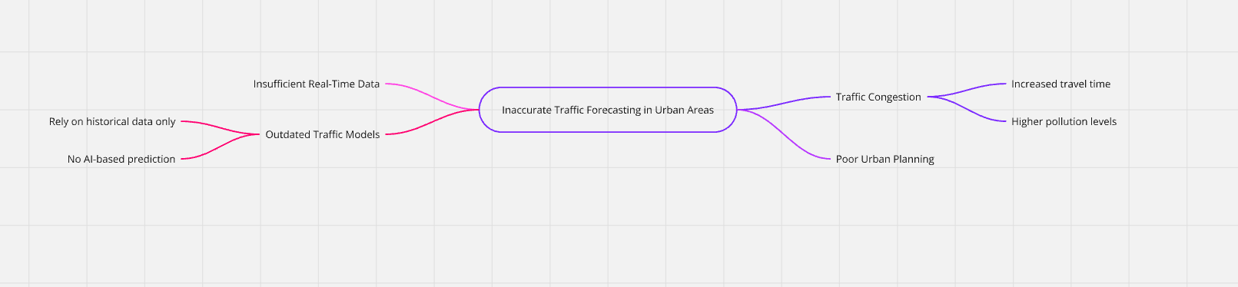

Reference: <https://miro.com/templates/customer-problem-statement/>

**Example:**

|  |  |  |  |  |  |
| --- | --- | --- | --- | --- | --- |
| **Problem Statement (PS)** | **I am (Customer)** | **I’m trying to** | **But** | **Because** | **Which makes me feel** |
| PS-1 | a daily commuter in a busy city | reach my workplace on time | traffic conditions change suddenly without accurate info | I don't have access to reliable and predictive traffic updates | frustrated, anxious, and often late |
| PS-2 | a city traffic control authority | manage traffic efficiently during peak hours and rains | I don’t have real-time predictive data to act proactively | current tools only give live status, not future estimates | helpless, reactive instead of proactive |